**Analytic Trigonometry Homework Problems**

****1) The base of the Louvre Pyramid covers 11,000 square feet

What is the length of each side of the pyramid at its base?

(Hint: this would be the square root. Use your calculator)

Round to the nearest 10th of a foot

Be sure to include the units (feet)

2) The height of the Louvre Pyramid is 71 feet



**71 ft**

Half of what you calculated in problem 1

Hypotenuse

How far would Spiderman climb if he scaled e

the hypotenus of the pyramid?

Round to the nearest 10th of a foot

Be sure to include the units (feet)

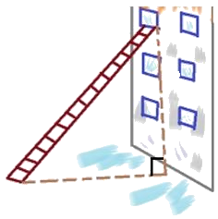3) A fire department has a 30 foot ladder

How far from the burning building will they be setting the ladder

to reach a third story window 27 feet above the ground?

(round to the nearest 10th of a foot)

(be sure to include the units: feet)

Dinky King's creators have designed a new

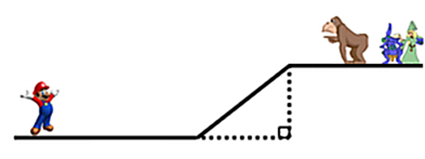

Murrio

12.9 cm

7 cm

5 cm

8.4 cm

Damsel

Dinky King

Platform game where the hero Murrio has to

race along various paths to save the damsel

4) How far does Murrio have to travel to save the

damsel?

(round to the nearest 10th of a cm)

(be sure to include the units: cm)

8.4 cm

19.9 cm

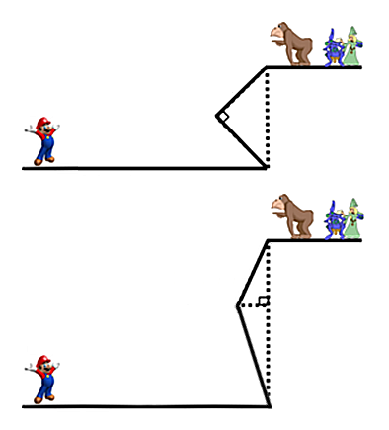

Murrio

Damsel

"x"

"x"

9.9 cm

Dinky King

8.4 cm

5) How far does Murrio have to travel to save the

damsel?

(round to the nearest 10th of a cm)

(be sure to include the units: cm)

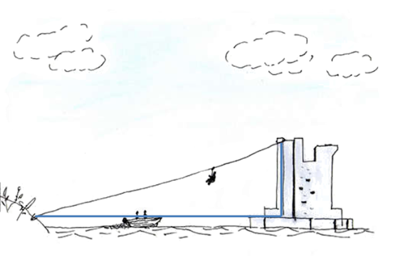6) How long a rope will the saboteurs

need to access the 120 foot

high castle 150 feet away?

**Sightlines on the Earth**

A person can see only a few miles because of the curvature of the Earth

In the middle of the ocean, the formula to find how far you can see (to the visual "horizon") is

*d* = 

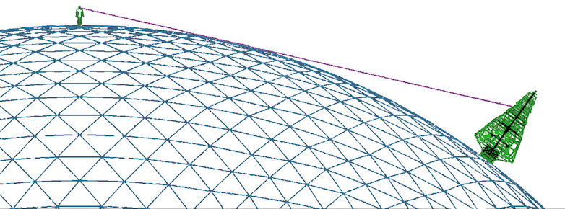

Absolutely NOT to scale!

where *d* is the distance in miles

that you can see and

*h* is the height of the viewer's eye

in feet

As you can probably detect - this comes from the Pythagorean Theorem,

complicated by the fact that the Earth is curved, not flat

7) Assuming a six–foot person with a height to their eye of 5.5 feet, how far away is this

person's visual horizon? (don't forget the units!!!)

8) Can the person see an island 7 miles away?

9) The Gazela of Philadelphia is the oldest and largest wooden sailing ship still putting out

to sea

When a person is in its crow’s nest, that person's eye height is about 150 feet

How far could a person in this crow's nest see (don't forget the units!!!)?

10) Can the person in the crow's nest see an island 7 miles away?

11) How high would a crow's nest platform have to be to see an

island 20 miles away?

**Extra Credit Video Research**

Please watch the "Tree Trig" video in <http://vf-tropi.com/trig.html>

11) Explain why the "Stick Method" works to find the height of the tree:

Please watch the "How the Ancient Greeks Came Up with the Pythagorean Theorem" video in the same url

12) Explain how the ancient Greeks viewed the Pythagorean Theorem: