Analytic Trigonometry Unit 04 Readings:

Transforming Trig Functions and More Trig Stuff

The trig graphs are "functions" - they have only one "y" value for each "x" value

"Natural" trig functions have not been transformed

Descriptors for the natural trig functions:

 | Max x | Min x | Max y | Min y | Period (rad) | Period (degrees)
sin | ∞ | -∞ | 1 | -1 | 2π | 360°
cos | ∞ | -∞ | 1 | -1 | 2π | 360°
tan | ∞ | -∞ | ∞ | -∞ | π | 360°
cot | ∞ | -∞ | ∞ | -∞ | π | 360°
sec | ∞ | -∞ | ∞ | -∞ | 2π | 360°
csc | ∞ | -∞ | ∞ | -∞ | 2π | 360°

Exact Values of trig Functions
Exact values for trig functions: the real/true EXACT values
Approximate values for trig functions: “close-enough” “good-enough” values that come out of
your calculator

Exact Values of Sin, Cos and Tan Functions

Deg | Rad | sin | cos | tan
0 | 0 | 0 | 1 | 0
30 | π/6 | 1/2 | $\sqrt{3}$/2 | $\sqrt{3}$/3
45 | π/4 | $\sqrt{2}$/2 | $\sqrt{2}$/2 | 1
60 | π/3 | $\sqrt{3}$/2 | 1/2 | $$\sqrt{3}$$
90 | π/2 | 1 | 0 | ∞
120 | 2π/3 | $\sqrt{3}$/2 | –1/2 | –$\sqrt{3}$
135 | 3π/4 | $\sqrt{2}$/2 | –$\sqrt{2}$/2 | –1
150 | 5π/6 | 1/2 | –$\sqrt{3}$/2 | –$\sqrt{3}$/3
180 | π | 0 | –1 | 0
210 | 7π/6 | –1/2 | –$\sqrt{3}$/2 | $\sqrt{3}$/3
225 | 5π/4 | –$\sqrt{2}$/2 | –$\sqrt{2}$/2 | 1
240 | 4π/3 | –$\sqrt{3}$/2 | –1/2 | $$\sqrt{3}$$
270 | 3π/2 | –1 | 0 | ∞
300 | 5π/3 | –$\sqrt{3}$/2 | 1/2 | –$\sqrt{3}$
315 | 7π/4 | –$\sqrt{2}$/2 | $\sqrt{2}$/2 | –1
330 | 11π/6 | –1/2 | $\sqrt{3}$/2 | –$\sqrt{3}$/3
360 | 2π | 0 | 1 | 0

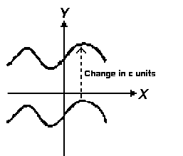
Transforming Functions (algebra review)

vertical shifts
y = ƒ(x) = squiggly line
g(x) = ƒ(x) + c
a positive "c" shifts the curve up
a negative "c" shifts the curve down

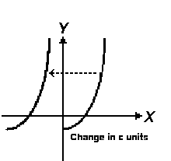
horizontal shifts
y = ƒ(x)
g(x) = ƒ(x + c)
a positive "c" shifts the curve left
a negative "c" shifts the curve right
(counter-intuitive)

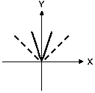
vertical & horizontal stretching & shrinking
if c>1 y = c ƒ(x)
stretches vertically
if 0<c<1 y = c ƒ(x)
shrinks vertically
if c>1 y = ƒ(cx)
shrinks horizontally
(counter-intuitive)
if 0<c<1 y = ƒ(cx)
stretches horizontally
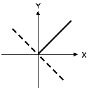
(counter-intuitive)

reflection
y = − ƒ(x)
reflects about the x-axis
y = ƒ(−x)
reflects about the y-axis

Transforming Trig Functions
The general forms of the trig equations are:

y = A sin (Bx - C) + D y = A cos (Bx - C) + D
y = A tan (Bx - C) + D y = A cot (Bx - C) + D
y = A sec (Bx - C) + D y = A csc (Bx - C) + D

The multipliers A, B, C, D allow you to tweak the curves into different shapes

“A” stretches the graph up and down – “Amplitude”
“B” stretches the graph side to side – “Period”
“C” moves the graph side to side – “Phase shift”
“D” moves the graph up and down – “Vertical shift”

Notice the "C" is subtracted - that makes it more intuitive!
Think of "B" as "frequency" - a large number cycles around more frequently

For: y = A sin (Bx - C) + D
y = A cos (Bx - C) + D

amplitude = |A|
period = 2π /B B = period/2π frequency = $\frac{ QUOTE \sqrt{3 } 1}{period}$
phase shift = C/B C = phase shift × period/2π
(moves starting point from x = 0 to x = C/B)
vertical shift = D
For: y = A tan (Bx - C) + D
y = A cot (Bx - C) + D

amplitude = |A|
period = π /B B = period/π frequency = $\frac{ QUOTE \sqrt{3 } 1}{period}$

phase shift = C/B C = phase shift × period/π
(moves starting point from x = 0 to x = C/B)
vertical shift = D
For: y = A sec (Bx - C) + D
y = A csc (Bx - C) + D

amplitude = |A|
period = 2π /B B = period/2π frequency = $\frac{ QUOTE \sqrt{3 } 1}{period}$

phase shift = C/B C = phase shift × period/2π
(moves starting point from x = 0 to x = C/B)
vertical shift = D

Is my function transformed?

If the tops and bottoms of the sine/cosine curves are at 1 and -1, it is a “regular” curve

(“A” is 1)

If the inflexion point of a tan/cot curve is at the x-axis, it is a “regular” curve (“A” is 1)

If the tops and bottoms of the “Us” for sec /csc curves are at 1 and -1, it is a “regular” curve

(“A” is 1)

Which function corresponds with the graph:
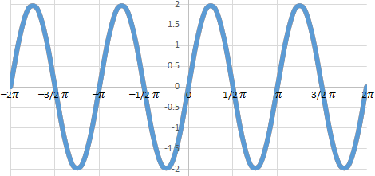

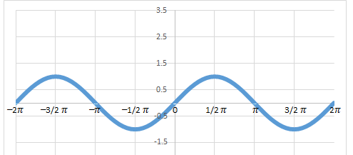

Which graph is it?
A sine…
Start with the standard sine graph:
It has amplitude 1
It has a period of 2 𝜋

a) y = 2sin (2x) b) y = 3sin (3x):
Twice the frequency
Twice the amplitude

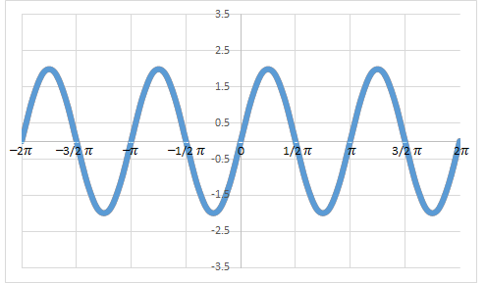
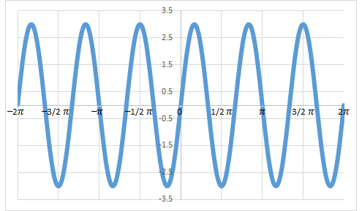

c) y = sin (2x): d) y = 2sin (x/2):
