**Analytic Trigonometry Unit 06 Problems**

**Review**

**Angles and Triangles**

III

IV

II

I

1) The given angle 8π/15 is in standard position.

Calculate the quadrant in which the angle lies:

a) I b) II

c) III d) IV

2) Classify the given angle: π/16

a) Acute b) Right c) Obtuse d) Straight

sin(*θ*) = rise or . opposite .

hypotenuse hypotenuse

cos(*θ*) = run . or . adjacent .

hypotenuse hypotenuse

tan(*θ*) = rise or opposite

run adjacent

cot(*θ*) = run or adjacent

rise opposite

sec(*θ*) = hypotenuse or hypotenuse

run adjacent

csc(*θ*) = hypotenuse or hypotenuse

rise opposite

3) For the triangle shown, calculate:

a

b

1

37º

a =

**Trigonometry**

4) For the triangle shown, calculate:

.9761

.2171

1

*θ*

tan(*θ* ) =

5) Simplify sin2 (7π/52) + cos2 (7π/52)

a) 2 b) 1

c) 3 d) 10

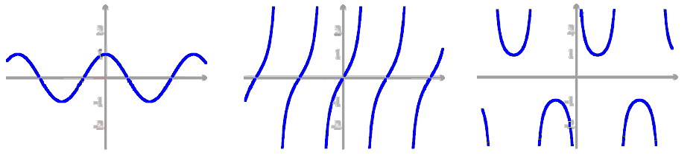6) Identify the type of trig graph:

a) sin b) cos

c) tan d) cot

e) sec f) csc

**Degrees and Radians**

7) Convert 71.4º to radians

**Degrees to Radians** multiply degrees by: 

**Radians to Degrees** multiply radians by: 

8) Convert 6π/23 to degrees

9) Calculate the value of sin 7π/15 (remember to change your calculator to radians)

|  |  |  |  |  |
| --- | --- | --- | --- | --- |
| **Exact Values of Trig Function** | | | | |
| **Deg** | **Rad** | **sin** | **cos** | **tan** |
| 0 | 0 | 0 | 1 | 0 |
| 30 | π/6 | 1/2 | $\sqrt{3}$/2 | $\sqrt{3}$/3 |
| 45 | π/4 | $\sqrt{2}$/2 | $\sqrt{2}$/2 | 1 |
| 60 | π/3 | $\sqrt{3}$/2 | 1/2 | $$\sqrt{3}$$ |
| 90 | π/2 | 1 | 0 | ∞ |
| 120 | 2π/3 | $\sqrt{3}$/2 | –1/2 | – $\sqrt{3}$ |
| 135 | 3π/4 | $\sqrt{2}$/2 | – $\sqrt{2}$/2 | –1 |
| 150 | 5π/6 | 1/2 | – $\sqrt{3}$/2 | – $\sqrt{3}$/3 |
| 180 | π | 0 | –1 | 0 |
| 210 | 7π/6 | –1/2 | – $\sqrt{3}$/2 | $\sqrt{3}$/3 |
| 225 | 5π/4 | – $\sqrt{2}$/2 | – $\sqrt{2}$/2 | 1 |
| 240 | 4π/3 | – $\sqrt{3}$/2 | –1/2 | $$\sqrt{3}$$ |
| 270 | 3π/2 | –1 | 0 | ∞ |
| 300 | 5π/3 | – $\sqrt{3}$/2 | 1/2 | – $\sqrt{3}$ |
| 315 | 7π/4 | – $\sqrt{2}$/2 | $\sqrt{2}$/2 | –1 |
| 330 | 11π/6 | –1/2 | $\sqrt{3}$/2 | – $\sqrt{3}$/3 |
| 360 | 2π | 0 | 1 | 0 |

**Exact Values**

10) Calculate the exact value of sin(7𝜋/6)

11) Calculate the exact value of cot (𝜋/6)

**Transforming Graphs**

12) What is the amplitude of the graph?

**8**

a) 8

**4**

b) 16

π

2π

-π

-2π

**0**

c)2𝜋

**0**

**- 4**

d) 𝜋

**- 8**

13) What is the period of the graph?

π

2π

-π

-2π

**0**

**1**

**- 1**

**0**

a) 1

**0.5**

b) 2

c)𝜋

**-0.5**

d) 2𝜋

14) The period of a transformed sine function is 7𝜋/2. What is the frequency?

**Inverse Trig Functions**

15) Calculate the angle in degrees: sin−1(-0.6218) =

(remember to change your calculator to degrees)

16) Calculate the angle in radians: cos−1(7𝜋) =

(remember to change your calculator to radians)

17) Calculate the angle in degrees: tan−1(42.5) =   
 (remember to change your calculator to degrees)

**RC Circuit Analysis**

**Impedance**

Z = $\sqrt{R^{2}+{X_{C}}^{2}}$

**phase angle**

*θ* = tan-1

R

XC

12Ω

90Ω

~

VS

18) Calculate the impedance of the RC circuit:

19) Calculate the phase angle of the RC circuit:

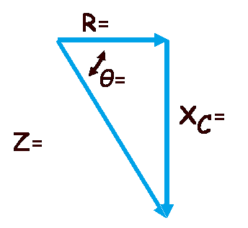20) Fill in the impedance triangle values:

**Area of an Oblique Triangle**

21) Calculate the area of a triangle with two sides 8 meters and 12 meters and an included

angle of 110° (don't forget the units!)

**Heron’s formula**

22) Calculate the area of a triangle with a = 6 in, b = 16 in, and c = 18 in (don't forget the

units!)

**Law of Sines and Cosines**

For triangle problems in this assignment, use the angle side labels as shown below:

A

B

C

a

b

c

Note: The triangle is not drawn to scale.

23) Given that A = 69º

a = 25 ft

b = 16 ft Calculate angle B to the nearest degree.

a) 74º b) 37º

c) 59º d) 63º

24) Given that a = 10 mm

b = 40 mm

A = 30º Calculate if there is:

a) One triangle b) Two triangles c) No triangles

25) Given that B = 45º

a = 2 yds

c = 4 yds What is angle C? Hint: Use the Law of Cosines only

a) 29º b) 106º c) 77º d) 74º

26) Calculate the value of angle A, given that: a is 6"

b is 8"

c is 8"

a) 67º b) 44º c) 23º d) 113º

Notation: **N35ºE means 35º east of due north**

**N49ºW means 49º west of due north**

27) Two fire lookout stations are 13 miles apart, with station B directly east of station A

Both stations spot a fire

The bearing of the fire from station A is N35oE

and the bearing of the fire from station B is N49oW.

How far (to the nearest tenth of a mile) is the fire from station b? (don't forget the units!)

28 A plane leaves airport A and travels 580 miles to airport B on a bearing of N34ºE.

The plane later leaves airport B and travels to airport C 400 miles away on a

bearing of S74ºE.

Calculate the distance from airport A to airport C to the nearest tenth of a mile.

(don't forget the units!)

**Extra Credit**

The leaning tower of Pisa is inclined 5.5 degrees from the vertical

At a distance of 100 meters from the wall of the tower, the angle of elevation to the top is 30.5

degrees

Draw the picture of what is going on and attach it to this document

Use the law of sines to estimate the height of the leaning tower (: