Analytic Trigonometry Unit 07 Readings:

Complex Numbers

Complex numbers
remember:
≡ means "is defined to be"
"imaginary" unit i ≡ $\sqrt{-1}$
complex numbers have a real and an imaginary part: a + bi
every real number is a complex number in which the imaginary part equals zero

usually designated "z"
Rules for complex numbers:
equality: a + bi = c + di if a=c and b=d
addition: (a + bi ) + (c + di) = (a + c) + (b + d) i
subtraction: (a + bi ) – (c + di) = (a – c) + (b – d) i
complex conjugate: (a + bi ) × (a – bi) = a ²+ b ²
For $\sqrt{-n}$ ALWAYS TAKE OUT THE “i ” first!
$\sqrt{-4}$ = i $\sqrt{4}$ = 2 i
$\sqrt{-9}$ × $\sqrt{-36}$ = 3i × 6i = 18i² = –18 (the right answer)
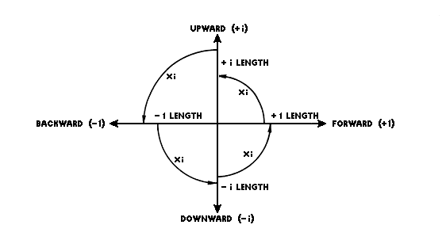
If you don’t take out the “i ” first:
$\sqrt{-9}$ × $\sqrt{-36}$ = $\sqrt{324}$ = 18 (the wrong answer)

The Complex Plane
imaginary unit i = $\sqrt{-1}$
i = $\sqrt{-1}$
i ² = –1
i ³ = – i
i ⁴ = 1
i ⁵ = i
.
.
.
complex numbers can be plotted
as points on the complex plane
real axis (horizontal) and an
2+3i
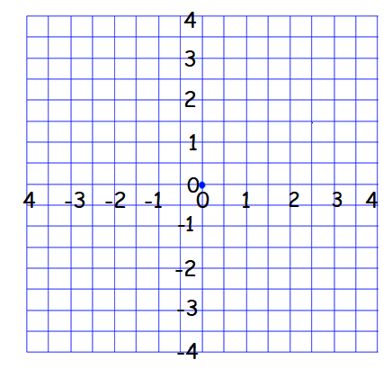
imaginary axis (vertical)

Graphing Complex Numbers
–2+i
We call the graph paper the "complex plane"
Given a complex number, to represent its components:
Move along the horizontal axis the amount of the real part
1.5–2.5i
Move parallel to the vertical axis the amount of the imaginary part
Plot the point

Complex Numbers in Electronics
A common situation in electrical networks is the existence of many sine-shaped waves all with
the same frequency but with different amplitudes and phases
They are represented by a real multiplier for frequency and time and a complex multiplier for
amplitude (phasor)
Combining these phasors is called phasor arithmetic

In AC circuits, resistors, capacitors, and inductors can be combined in a single complex
number called the impedance (in ohms, Ω):
Z = R + j·X
R is the resistance (a real number)
X is the reactance (imaginary)
These are generally written:
Z = (17 + j·1.5)Ω
The imaginary unit, i, is represented by the letter "j", to avoid confusion with current (Ɪ )
If two impedances are connected in series, the equivalent impedance is obtained by addition:
Z_{e}= Z₁ + Z₂
The total impedance z_{T} in a parallel circuit composed of circuits z₁ and z₂ is given by the formula: z_{T} = $\frac{z_{1}z_{2}}{z_{1}+z_{2}}$
Kirchhoff's circuit laws (you will be running into them in your electrical engineering courses) work with phasors in complex form

