**Colorado Technical University**

**Course:** MATH116 – Foundations for Calculus

#### Unit 1 Part 01 Readings: Functions and Mathematical Modeling

**Functions**



An ***x* can have only one *y***

For every “*y*” you can have more than one “*x*”

**Graphs of Common Functions**

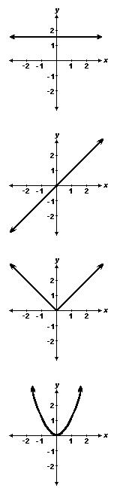

Constant Function

ƒ(*x*) = *c*

domain =

range =

increasing / decreasing

even / odd

Identity Function

ƒ(*x*) = *x*

domain =

range =

increasing / decreasing

even / odd

Absolute Value Function

ƒ(*x*) = |*x|*

domain =

range =

increasing / decreasing

even / odd

Quadratic Function

ƒ(*x*) = *x*2

domain =

range =

increasing / decreasing

even / odd

Square Root Function

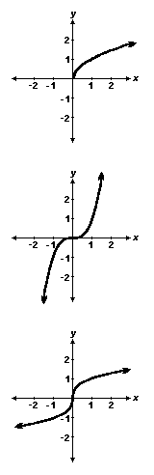ƒ(*x*) = **

domain =

range =

increasing / decreasing

even / odd

Cubic Function

ƒ(*x*) = *x*3

domain =

range =

increasing / decreasing

even / odd

Cube Root Function

ƒ(*x*) = **

domain =

range =

increasing / decreasing

even / odd

# Transforming Functions

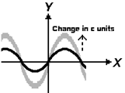**vertical shifts**

*y* = ƒ(*x*) + c plus shifts up

*y* = ƒ(*x*) – c minus shifts down

vertical stretching & shrinking

if c>1 *y* = c ƒ(*x*)

stretches vertically

if 0<c<1 *y* = c ƒ(*x*)

shrinks vertically

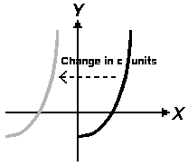

**horizontal shifts**

*y* = ƒ(*x*)

*y* = ƒ(*x* – c)

minus shifts right (counter-intuitive)

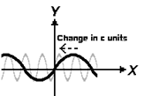

horizontal stretching & shrinking

if c>1 *y* = ƒ(c*x*)

shrinks horizontally

if 0<c<1 *y* = ƒ(c*x*)

stretches horizontally

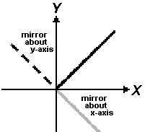

**reflection**

*y* = -ƒ(*x*)

reflects about the *x*-axis

*y* = ƒ(-*x*)

reflects about the *y*-axis

**Mathematical Modeling**

Functions are often used to model real-world phenomena

A **mathematical model** is a mathematical description (often by means of a function or

an equation) of a real-world phenomenon

The purpose of the model is to understand the phenomenon and often to make

predictions about future behavior (**forecasts**)

A mathematical model is never a completely accurate representation of a physical

situation

Unless it was developed as part of a scientific experiment to show the particular

relationship, while it may be useful for forecasting, there is no scientific evidence

to show a particular model accurately explains a phenomenon

