Colorado Technical University
Course: MATH116 – Foundations for Calculus

Unit 2 Part 03 Readings: Lines and Quadratics (Parabolas)

Lines

What defines a line?
To define a unique line, you need:
two points or a point and a slope

Slope of a line
rise y₁ − y₂
.
run x₁ − x₂

m = =

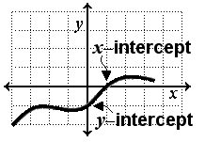
Intercepts
the x-intercept is the x value where y = 0
the y-intercept is the y value where x = 0

y-intercept
b = y – mx

Equations of a line
Point-slope form: y – y 1 = m(x – x₁) where (x₁, x₁) is a given point
Slope-intercept form: y = mx + b

Vertical line
x = a, where a is the x-intercept
(slope is undefined)

Horizontal line
y = b, where b is the y-intercept

Parallel Lines
have the same slope

Perpendicular lines
the product of their slopes is –1

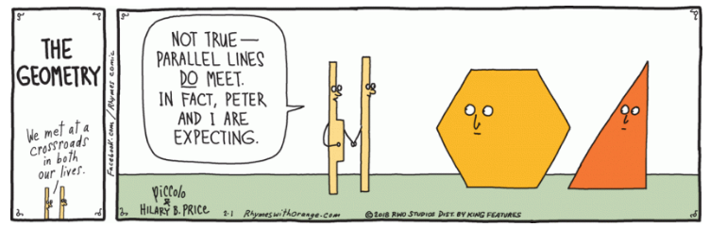
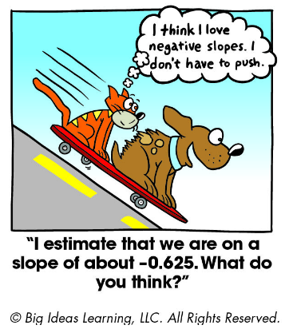
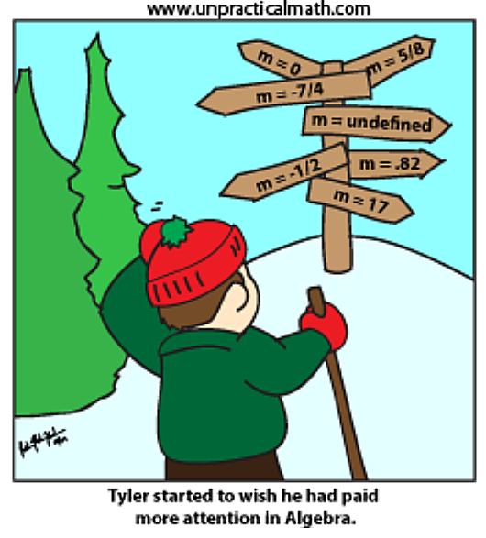
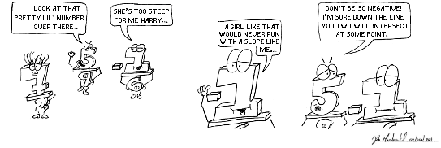

Parabolas and Quadratic Equations

Parabolas:
y = x² y = x² + 4 y = x² − 4 y = −(x²) + 20
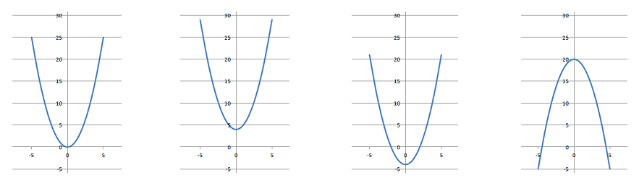

In general, the equation for a parabola is: ax² + bx + c = y

Shapes of the curve:

The constant at the end moves the curve vertically up or down

A coefficient (greater than one) for the x² term makes the curve skinnier

A negative coefficient for the x² term makes it a "hill" rather than a "cup"

A positive coefficient for the "x" term moves it both vertically and horizontally

A negative coefficient for the "x" term moves it up and to the left

Quadratic formulas

Equations of parabolas are called "quadratic"

An equation in which one or more of the terms is squared but raised to no higher power

The "quad" is because they are "squared"

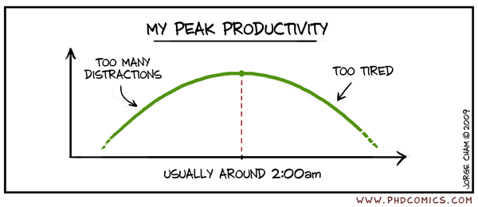
Quadratic formulas are of the form: ax² + bx = c

