**Colorado Technical University**

**Course:** MATH116 – Foundations for Calculus

**Unit 4 Part 08 Readings: Rational Equations**

**Rational equations**

Simplifying fractions

Make it proper ***using long division***

Cancel any common factor in the numerator and denominator

**Algebraic ratios**

The quotient of two polynomial expressions

Get all denominators alike and cancel

Multiplying rational expressions: $\frac{a}{b}×\frac{c}{d}=\frac{a×c}{b×d}$

Dividing rational expressions: $\frac{a/b}{c/d}=\frac{a}{b}×\frac{d}{c}$

**Canceling to simplify fractions:**  

Fraction addition/subtraction when the denominator is the same

If two fractions have the same denominator (number below the division line) addition (or subtraction) is EASY! Keep the denominator the same and add (or subtract) the numerators:



(Note: the units of measurement must also be the same)

Example: 

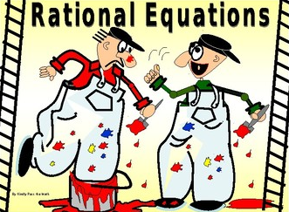

Example: 

