**Colorado Technical University**

**Course:** MATH116 – Foundations for Calculus

### Unit 6 Part 12 Readings: Logarithms and Exponentials

**Logarithms**

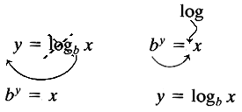log2 16 *2 to what power gives 16?*

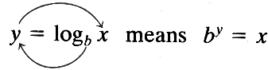

log2 16 = 4 *because* 24 = 16

if logb M = logb N then M = N

logb bx = x

blogb x = x inverse properties

rule for changing the base of logarithms: logbM = logaM/loga

**Natural Logarithms**

logs with base *e*

written "ln"

logb 1 = 0 ln 1 = 0

logb b = 1 ln *e* = 1

logb bx = x ln *e*x = x

blogb x = x *e*lnx = x inverse properties

log10(e) = 1/ln(10)

**Logarithmic Equations**

Change of base:

logbM = logaM/loga b = lnM/ln b

Rules for using logarithms:

for M>0 and N>0:

logbM + logbN = logb (MN)

logbM  logbN = logb (M/N)

p logbM = logb Mp

Equality:

if bM = bN then M = N

if a = b then ln(a) = ln(b)

if logb M = logb N then M = N

**Exponents**

Functions that contain exponents: f(x) = xc

x is the base, c is the exponent

Exponential functions: f(x) = cx

c is the base, x is the exponent

Limitations: the base must be a constant

the base must be >1

the exponent must not be a variable

Use the yx or ^ or exp key on your calculator

Graphs of exponential functions:



f(x) = (½)x



f(x) = 2x

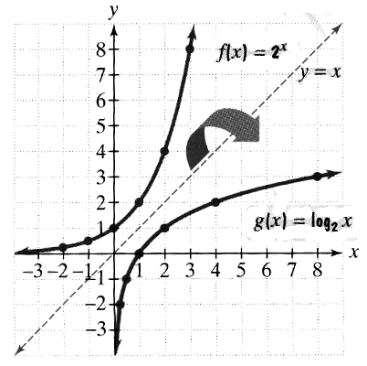**Graphs of Exponentials vs Logarithms:**

Exponents and logarithms are inverses of each other

