Colorado Technical University
Course: MATH116 – Foundations for Calculus

Unit 7 Part 13 Readings: Growth and Decay Models

Growth Models
Exponential Models Logarithmic Models
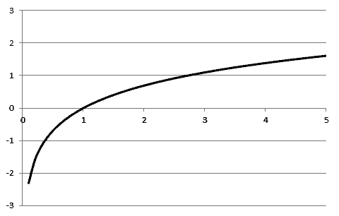
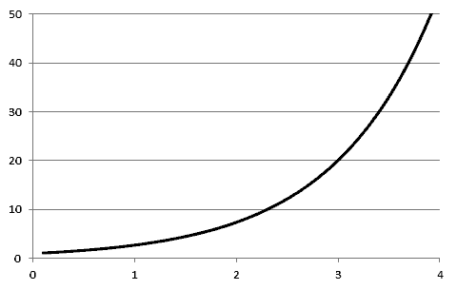

Start slow then speed up Start fast then slow down

Compound Interest: A = P(1+r/n)^{nt}
A = accumulated value
P = the principal amount of money
t = years
r = annual percentage rate (in decimal form)
n = compounded n times per year

Population Growth: A = A₀ e^{kt}
A = amount at time t
r = growth rate
A₀ = original amount
if k > 0 then the population is growing
if k < 0, then the population is shrinking

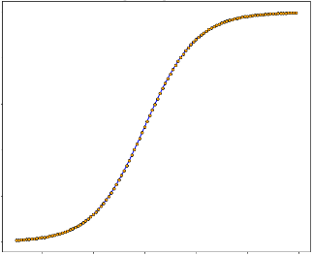
Logistic Growth (growth within a limit): A = c/ (1+ ae^{-bt})
c > 0
b > 0
as time t increases:
ae^{-bt} approaches 0
A gets closer to the limit c

Min + (Max-Min)/(1+e^(-rate*(day-inflexion pt)))
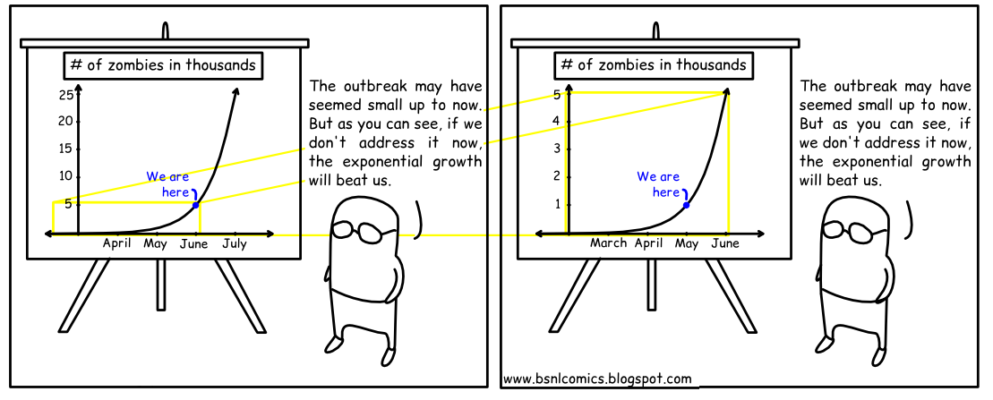
NOW
LAST MONTH
WHY I DON’T TRUST EXPONENTIAL GRAPHS

