Colorado Technical University
Course: MATH205 – Differential Calculus

Unit 8 Part 16 Readings – Reverse Chain Rule

Reverse Chain Rule: ∫ u^{n} du = $\frac{u^{n+1}}{n+1}$ + c

The Reverse Chain Rule is also called “integration by substitution” or “u-substitution”
Derivatives of Transcendental Functions (used in Reverse Chain Rule problems)

$\frac{d}{dx}$ sin u = cos u $\frac{du}{dx}$ $\frac{d}{dx}$ cot u = csc ² u $\frac{du}{dx}$

$\frac{d}{dx}$ cos u = –sin u $\frac{du}{dx}$ $\frac{d}{dx}$ sec u = sec u tan u $\frac{du}{dx}$

$\frac{d}{dx}$ tan u = sec² u $\frac{du}{dx}$ $\frac{d}{dx}$ csc u = csc u cot u $\frac{du}{dx}$

$\frac{d}{dx}$ sin⁻¹ u = $\frac{1}{\sqrt{1-u^{2}}}$ $\frac{du}{dx}$ $\frac{d}{dx}$ cot ⁻¹ u = $-\frac{1}{\sqrt{1+u^{2}}}$ $\frac{du}{dx}$

$\frac{d}{dx}$ cos⁻¹ u = $-\frac{1}{\sqrt{1-u^{2}}}$ $\frac{du}{dx}$ $\frac{d}{dx}$ sec⁻¹ u = $\frac{1}{\left|u\right|\sqrt{1-u^{2}}}$ $\frac{du}{dx}$

$\frac{d}{dx}$ tan⁻¹ u = $\frac{1}{\sqrt{1+u^{2}}}$ $\frac{du}{dx}$ $\frac{d}{dx}$ csc⁻¹ u = $-\frac{1}{\left|u\right|\sqrt{1-u^{2}}}$ $\frac{du}{dx}$

$\frac{d}{dx}$ log_{b} u = 1/(u ln(b)) $\frac{du}{dx}$ $\frac{d}{dx}$ b^{u} = b^{u} ln(b) $\frac{du}{dx}$

$\frac{d}{dx}$ ln u = $\frac{1}{u}$ $\frac{du}{dx}$ $\frac{d}{dx}$ e^{u} = e^{u}$\frac{du}{dx}$
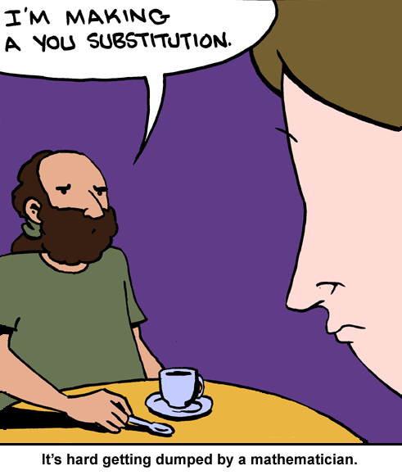

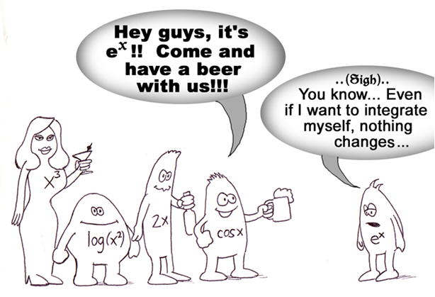

Area Under a Curve

