**Colorado Technical University**

**Course:** MATH207 – Integral Calculus

### Unit 1 Part 2 Readings: Calculus of Logarithms and Exponentials

**Logarithms**

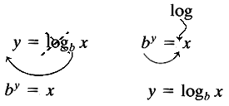log2 16 *2 to what power gives 16?*

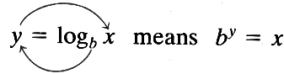

log2 16 = 4 *because* 24 = 16

if logb M = logb N then M = N

logb bx = x

blogb x = x inverse properties

rule for changing the base of logarithms: logbM = logaM/loga

**Natural Logarithms**

logs with base *e*

written "ln"

logb 1 = 0 ln 1 = 0

logb b = 1 ln *e* = 1

logb bx = x ln *e*x = x

blogb x = x *e*lnx = x inverse properties

log10(e) = 1/ln(10)

**Calculus of Logarithms**

**Derivatives:** d(loga(u))/dx = 1/u loga(e) du/dx

**Integrals: ∫** loga(x) dx = xloga(x) – x/ln(a) +c = (xln(x) – x)/ln(a) +c

**∫** ln(ax) dx = xln(ax) – x +c

**∫** ln(ax+b) dx = ((ax+b)ln(ax+b)-(ax+b))/a +c

**∫** ln(x)2 dx = x(ln(x))2 – 2xlnx + 2x +c

**Exponents**

Functions that contain exponents: f(x) = xc

x is the base, c is the exponent

Exponential functions: f(x) = cx

c is the base, x is the exponent

Limitations: the base must be a constant

the base must be >1

the exponent must not be a variable

Use the yx or ^ or exp key on your calculator

Graphs of exponential functions:



f(x) = (½)x



f(x) = 2x

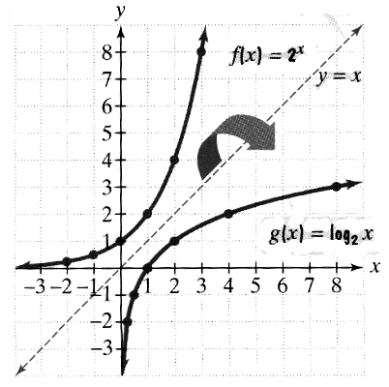**Graphs of Exponentials vs Logarithms:**

Exponents and logarithms are inverses of each other

**Exponential Calculus**

**Derivatives**: d(ex)/dx = ex

d(eu)/dx = eu du/dx

$\frac{d}{dx}$ bu = bu ln(b) $\frac{du}{dx}$

**Integrals: ∫** ex dx = ex +c

**∫** eax dx = (1/a) eax +c

**∫** abx dx = $\frac{\text{a}\text{bx}}{\text{b ln(a)}}$ +c

