Colorado Technical University
Course: MATH207 – Integral

Unit 3 Part 6 Readings: Volumes

Area A under a curve y = f(x) from x = a to x = b is
lim
n→∞
A = sum of the n rectangles between a and b
= ∫_{a}^{b} f(x) dx
b
a
= F(x) |
= F(b) − F(a)
where F(x) = ∫ f(x) dx note: no constant of integration!

Definite Integral
If f(x) is a continuous function between x = a and x = b and the
derivative of F(x) = F'(x) is f(x) then
∫_{a}^{b} f(x) dx = F(b) - F(a)
b
a
= F(x) |

Factoid: ∫_{a}^{b} f(x) dx = − ∫_{b}ª f(x) dx

Area between two curves f and g
A = ∫_{a}^{b} f(x) - g(x) dx

Volumes of Revolution
Find the volume of a solid created by revolving a function about an axis
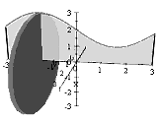
Disk method
infinitesimally thin circular slices added together to
get the volume
the formula for calculating the volume of a solid
formed by revolving a function f(x) about the
x-axis axis is:
π∫_{a}^{b}[ f(x)] ² dx
the formula for calculating the volume of a solid
formed by revolving a function f(y) about the y-axis axis is:
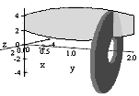
π∫_{a}^{b}[ f(y)] ² dy

Ring Method

When two curves are rotated about an axis, the

resulting shape can be sliced into an

infinitesimally-thin set of ring-shaped

(washer, donut, lifesaver, x-mas wreath) slices
Shell Method
Uses infinitesimally-thin cylindrical shells
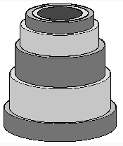
instead of disks or washers
V = sum of concentric cylindrical shells
 | radius | height | thickness | shells parallel to
V = | 2 π ∫_{a}^{b} x | f(x) | dx | y-axis
V = | 2 π ∫_{a}^{b} y | f(y) | dy | x-axis

