**Colorado Technical University**

**Course:** MATH207 – Integral Calculus

#### Unit 10 Part 19 Readings: Vectors

**Vectors**

## Vector quantities "vectors" - both magnitude and direction (N 5 mph)

Scalar quantities "scalars" - only magnitude (5 mph)

Directed line segment - from initial point to terminal point PQ

**Magnitude** = length || PQ || = distance from P to Q

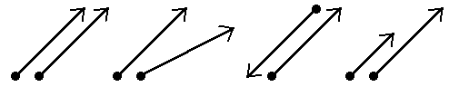Vectors denoted by boldface letters: **v** **w**

**v** = **w** same magnitude same magnitude different magnitude

different direction opposite direction same direction

**Magnitude** of a vector **v** (distance between initial point (*x*1,*y*1)

and terminal point (*x*2,*y*2): || **v** || =

## Direction can be shown by slope: m = $\frac{y_{1}-y_{2}}{x_{1}-x_{2}}$ if $x_{1}-x_{2}$ ≠0

**Scalar multiplication** k**v**: positive real numberchanges the

magnitude |k| ||**v**|| but not the direction; negative points

it in the opposite direction

**Vector addition** **u** + **v**

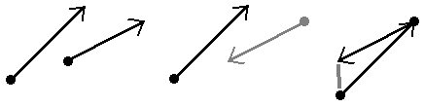Vector subtraction **u** - **v**

## Plotting vectors

vector **i** is the unit vector whose direction is along the positive *x*-axis

vector **j** is the unit vector whose direction is along the positive *y*-axis

vector **v** from (0,0) to (a,b): **v** = a **i** + b **j**

a and b are the scalar components of **v**

a is the horizontal component, b is the vertical component

**v** = a **i** + b **j** is a linear combination of **i** and **j**

||**v**|| = 

**Scalar multiplication:**

k**v** = (ka) **i** + (kb) **j**

**Position vector** –

if **v** doesn't start at (0,0):

**v** = (x2 – x1) **i** + (y2 – y1) **j**

**Writing a vector in terms of its magnitude and direction**

magnitude ||**v**|| direction angle *θ*

**v** = ||**v**||(cos *θ* **i** + sin *θ* **j**)

## The Dot Product - multiplying two vectors

**v** = a1 **i** + b1 **j**

**v ● w** = a1 a2+ b1 b2

**w** = a2 **i** + b2 **j**

**Cross Product**

notation: a × b (read "a cross b")

is a vector that is perpendicular to both a and b

defined only in three-dimensional space

Find the direction of the cross product by

the right-hand rule:

The magnitude is equal to the area of the

parallelogram that the vectors span

The cross product is defined to be:

a × b = ∥a∥ ∥b∥ sin(θ)n

where θ is the angle between a and b

in the plane containing them,

‖a‖ and ‖b‖ are the magnitudes

n is a unit vector perpendicular to the plane containing a and b in the direction

given by the right-hand rule

If two vectors have the same direction or have the exact opposite direction from one

another or if either one has zero length, then their cross product is zero

The magnitude of the product of two perpendicular vectors is the product of their lengths

Order IS important! a × b = − b × a

It is distributive over addition: a × (b + c) = a × b + a × c

Log on to the Internet and go to:

http://phet.colorado.edu/index.php

Under "How to Run Simulations" click "One at a Time"

Near the bottom of the list, click on "Vector Addition"

### In this simulation, you can stretch the vectors to change their magnitude and rotate and move the vectors to change their direction and location.



Vectors

compute properties of a vector

vector {2, -5, 4}

specify a vector as a linear combination of unit vectors

vector 3i + 5j

vector 2i - 4j + 3k

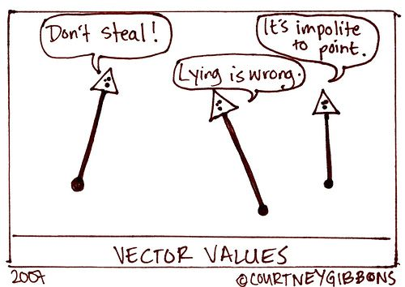

Vector Algebra

do vector computations

vector (1,3,-1) + (-2,1,6)

7 {1, 0, -2, 1} - 4 {2, -1, 1, -1}

(i + j + k) + (2i - 3j + 8k)

compute a dot product

{12, 20} . {16, -5}

(7i-j+3k).(4i-2k)

