Colorado Technical University
Course: MATH366 – Probability and Statistics

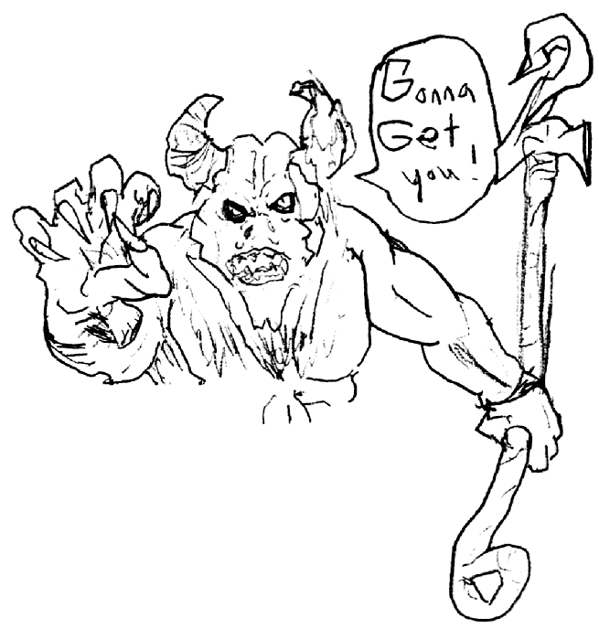
Unit 1 Part 01 Readings: Introduction, Sampling, Types of Data

Introduction to Statistics
Why do I have to take STATISTICS – terror of all college
students, bane of late-night comics???

Although maligned as "bean counters", statisticians do
more than just count, and rarely have anything to do
with beans (except eating them…)

Statistics is the basis for all the scientific claims you
hear about from Darwin's theory of Evolution to
commercials about the superiority of a certain brand
of aspirin. The government stands (nervously) on
Thanks to Jonathan Bellamy
for the stupendous
Stat Demon drawing !
statistical projections.

While few people will actually complete their own
statistical analysis, everyone is affected by statistics,
for good or ill.

Because it is true that statistics can be used to support anything (true or false),
everyone in the twenty-first century should become skeptical consumers of statistical information.

In this course we will learn how to do statistics, yes, but we will also learn how pervasive statistical lying is, and how to recognize a potential lie when we see one.
numbers DO lie !
statistics is the mathematics of uncertainty
it is the mathematics of our uncertain world
it is the mathematics of making decisions

Sampling
statistics - collecting, organizing, analyzing, and interpreting data in order to make
decisions
descriptive statistics: The branch of statistics that involves organization,
summarization, and display of data
inferential statistics: The branch of statistics that involves the use of a sample to
draw conclusions about a population
population - a collection of all outcomes, responses, measurements, and counts
that are of interest - the UNIVERSE
parameter - the numerical description of a characteristic of a population
census - a count or measure of an entire population

sample - a subset of a population
you want a sample that is representative of the population and
unbiased so your statistic is a good close estimate of your parameter of interest
statistic - the numerical description of a characteristic of a sample

To help ensure a representative sample:
Make sure every member of the population has an equal chance of being included -
a random sample
Take as large a sample as you can - the Law of Large Numbers
Types of data
qualitative - attributes, labels, or nonnumeric entries, ex: gender—male or
female
quantitative - numerical measurements or counts, ex: age—1, 2, 10, or 20
Other types of data:
Qualitative/quantitative – Some data can be described using a mathematical
formula/Others are so complicated we do not yet have a formula that works
Observation/experiment
Deterministic/nondeterministic
Periodic/nonperiodic – Some data cycle around/Others do not
Continuous/discrete – Some data can be ANY decimal value/Some data can only be
whole numbers
Stationary/nonstationary – Some data have a constant “average” value/Some data
have trend or displacement
Best descriptor statistics:
for qualitative data, use the “mode” (most frequently occurring value)
for quantitative data, use the traditional average (called an “arithmetic mean”)
Levels of measurement:
nominal - name only
ordinal - an ordering makes sense
interval - a meaningful spacing
ratio - you can compare one to the other as a percent or ratio
A weighted average can be used as a best descriptor for ordinal or interval data
Interval data with 5 or more categories can be treated as ration
Three criteria for good measurement:
reliability - an indicator of internal consistency; a measure is reliable when
different attempts at measuring something converge on the same result
validity - the accuracy of a measure or the extent to which a score truthfully
represents a concept
sensitivity - the ability to accurately measure the subtle variability in a concept

