Colorado Technical University
Course: MATH366 – Probability and Statistics

Unit 10 Part 19 Readings: Confidence Intervals for t and p

What if you have a sample size smaller than 20???
You must use a different (bigger) critical value
You will have a smaller interval if you have a larger value for n
Law of Large Numbers - if you take a larger and larger sample, your sample
statistic will become closer and closer to the real population parameter
We don't generally take repeated samples ourselves - we just take one sample and
assume it is from a population of samples that have these characteristics
We use this principal to test hypotheses about population parameters being within a
certain range

Confidence intervals when you aren’t sure you have a normal distribution
If you have samples from a normally-distributed population, no matter how small your
sample is, it’s values will be normally-distributed
If you have a “large-enough” sample size, irrespective of the population’s distribution, the
samples will be normally-distributed
BUT…
What if you have neither of these?
A very clever man W.S. Gossett (who worked for the Guinness brewery) was working with
sensory testing (flavor) of the vats of stout
Only a limited number of trained testers were available (about 5-7)
It seemed unlikely that flavor characteristics would follow a normal distribution (but might be
close)
Mr. Gossett invented a new continuous probability distribution for small samples from close-
to-normal populations
He called this the “t” (always small letter) distribution because he was using it to compare
two groups (“t” for two): the standard flavor and the flavor for a particular vat
Because he worked for a company (and companies don’t like their employees publishing
things) he published his ideas under the pseudonym “A Student”
So this distribution is called “Student’s t-Distribution”

The t distributions is wide (has thicker tails) than a standard normal distribution
The thick tails ensure that the confidence intervals are wider than those using a standard
normal distribution (and are better at including the population mean)

The formula for t:
t = $\frac{\overline{x}-μ}{s/\sqrt{n}}$
depends on the sample size n

The sample distribution of t = $\frac{\overline{x}-μ}{s/\sqrt{n}}$ is a t-distribution with n − 1 “degrees of freedom”
Written: t_{n-1}

The degrees of freedom (df) is a measure of how well s estimates σ
The larger the degrees of freedom, the better σ is estimated
We use n-1 rather than n degrees of freedom as a small penalty for reusing the same
dataset twice: once to calculate the mean $\overline{\text{x}}$ (estimating the population mean μ) and a second time to calculate the sample standard deviation s (estimating the population standard deviation 𝛔)

95% confidence interval for the mean: x̄ – t_{n-1} s/$\sqrt{n}$ ≤ μ ≤ $\overline{x}$x̄ + t_{n-1} s/$\sqrt{n}$
The “t_{n-1}” in the equations is called the “critical value”
It comes from the t-distribution

Traditionally, people had to use tables of these values
You looked up the “n – 1” value and the % confidence you needed to find the t-value
Nowadays, we use Excel or a variety of other on-line software systems:
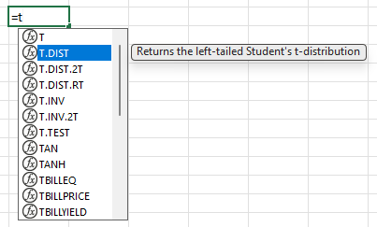
There are several “flavors” of “t” in
Excel
For confidence intervals, use:
t.inv.2t
the two-tail (we’re using “minus” the
value, and “plus” the value, so it’s two
tails)
Excel will want to know α (usually 5%)
and the degrees of freedom (n-1):

t.inv.2t(α,n-1)

Confidence Intervals for “p”
So far we have been doing confidence intervals for measurement data for population means
μ based on sample means x-bar
What about confidence intervals for population “p” values based on the “$\hat{p}$” of a sample?
$\hat{p}$ values are continuous – they can be ANY value from 0 to 1 on the real number line

These are easy, once you know the confidence intervals for the means
We’ll use the normal curve for proportions:
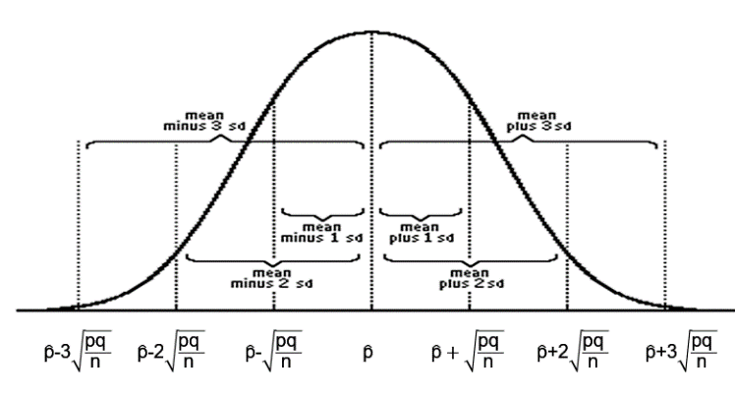

Notice the se for this type of data is: $\sqrt{\frac{pq}{n}}$
For normally distributed data or large sample sizes the margin of error will be 2se

The confidence interval will be:

$\hat{p}$ – 2$\sqrt{\frac{pq}{n}}$ ≤ p ≤ $\hat{p}$ + 2$\sqrt{\frac{pq}{n}}$

For small sample sizes from near-normal data, the confidence interval will be:

$\hat{p}$ – t_{n-1} $\sqrt{\frac{pq}{n}}$ ≤ p ≤ $\hat{p}$ + t_{n-1} $\sqrt{\frac{pq}{n}}$

