Colorado Technical University
Course: MATH207 – Integral Calculus

Unit 2 Part 3 Readings: Hyperbolic Functions

Hyperbolic Functions
Hyperbolic functions are analogues of the ordinary trigonometric functions, but defined using \ the hyperbola rather than the circle
Just as the points (cos(t), sin(t)) form a circle with a unit radius, the points (cosh(t), sinh(t))
form the right half of the unit hyperbola
Just as the slopes of sin(t) and cos(t) are cos(t) and -sin(t), the slopes of sinh(t) and cosh(t) are
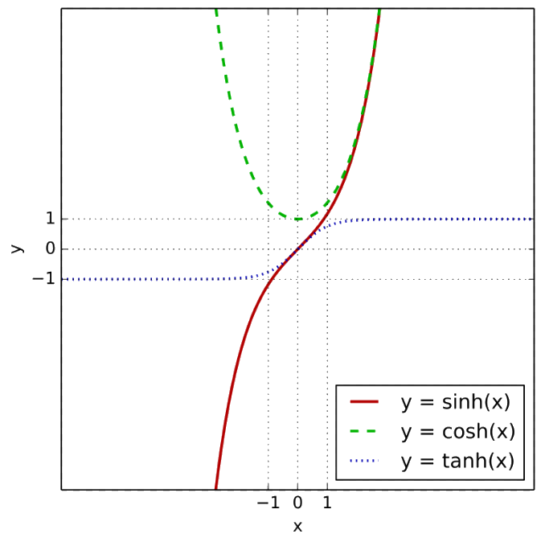
cosh(t) and +sinh(t)
Hyperbola

The hyperbolics can be defined in different ways:
in terms of exponentials: sinh(x) = (e^{x} – e^{-x})/2
cosh(x) = (e^{x} + e^{-x})/2
tanh(x) = (e^{x} - e^{-x})/(e^{x} + e^{-x})
in terms of complex trig functions: sinh(x) = - i sin(i x)
cosh(x) = cos(ix)
tanh(x) = -i (tan(i x)
If hyperbolics are being defined as exponentials, their inverses will be logarithms:
sinh⁻¹(x) = ln(x+$\sqrt{\text{x}\text{2}\text{+1}}$)
cosh⁻¹(x) = ln(x+$\sqrt{\text{x}\text{2}\text{-1}}$)
tanh⁻¹(x) = ½ln$\left(\frac{\text{1+x}}{\text{1-x}}\right)$

